**Macvlan Network :**

Macvlan is a Docker network driver that allows you to assign a MAC address to each container's network interface, making them appear as separate physical devices on the network. This can be useful in scenarios where you want containers to have their own unique presence on the network, similar to virtual machines or physical machines.

Here's an explanation of how to use Docker Macvlan network with an example:

Explanation:

1. Create a Macvlan Network:

* To create a Macvlan network, you need to specify the driver as macvlan when creating the network.
* You also need to provide details such as the parent interface (the physical network interface on your host), the mode (bridge, private, or passthrough), and a subnet.

1. Run Containers on the Macvlan Network:

* When you run a container, you need to specify the network using the --network option and set it to the name of the Macvlan network you created.
* Optionally, you can also set a static IP for the container within the specified subnet.

Example:

Let's assume you have a physical network interface on your host machine named eth0. Here's how you can create a Macvlan network and run a container on it.

1. Create a Macvlan network:

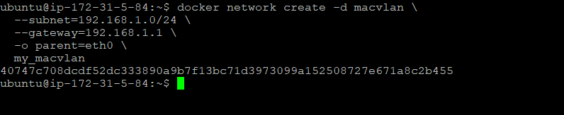

--subnet: Defines the subnet for the Macvlan network.

--gateway: Specifies the gateway for the subnet.

-o parent=eth0: Sets the parent interface to eth0.

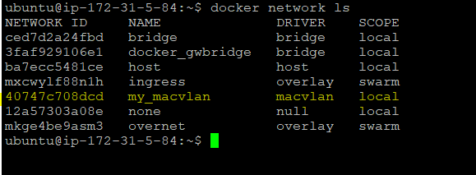

1. Run a container on the Macvlan network:

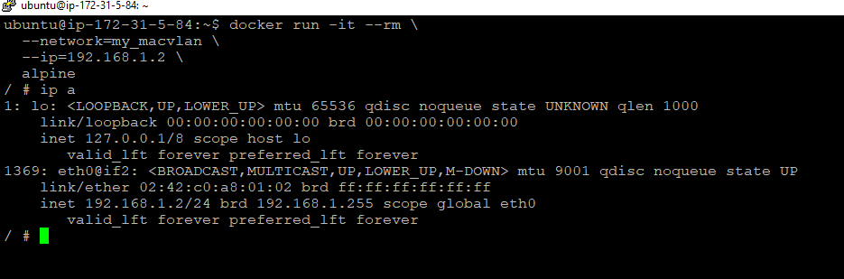

--network=my_macvlan: Connects the container to the my_macvlan network.

--ip=192.168.1.2: Assign a static IP address to the container.

Now, the container is running on the Macvlan network with its own MAC address and IP address, as if it were a separate device on the physical network.

Keep in mind that using Macvlan has some limitations and may not work well in certain environments, especially when dealing with DHCP or other dynamic network configurations. Always refer to the Docker documentation for the latest information and best practices.